Data Analytics with Tableau
Name: Mirza Tahseen Raza
Team Member-4
Assignment-3
Supermarket Sales Data Analysis Report – Interactive Dashboard using Tableau

Dashboard-1:
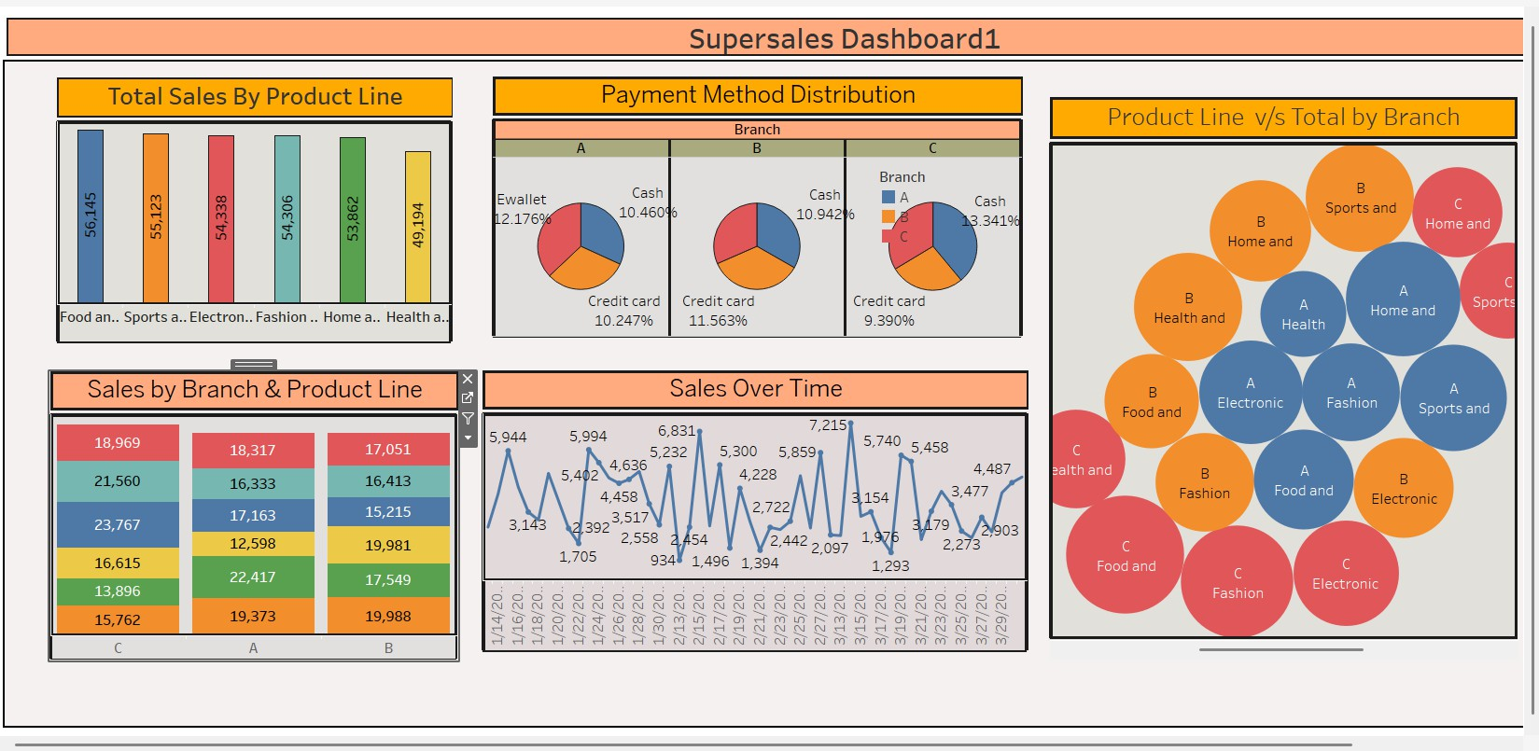

Dashboard-2:
